Chapter One
Programming Concepts
What is programming?
Programming refers to a technological process for telling a computer which tasks to perform in order to solve problems. You can think of programming as a collaboration between humans and computers, in which humans create instructions for a computer to follow (code) in a language the computer can understand.
Programming enables so many things in our lives. Here are some examples:
- When you browse a website to find information, contact a service provider, or make a purchase, programming allows you to interact with the site’s on-page elements, such as sign-up or purchase buttons, contact forms, and drop-down menus.
- The programming behind a mobile application can make it possible for you to order food, book a rideshare service, track your fitness, access media, and more with ease.
- Programming helps businesses operate more efficiently through different software for file storage and automation and video conferencing tools to connect people globally, among other things.
- Space exploration is made possible through programming.
How does computer programming work?
At its most basic, programming tells a computer what to do. First, a programmer writes code—a set of letters, numbers, and other characters. Next, a compiler converts each line of code into a language a computer can understand. Then, the computer scans the code and executes it, thereby performing a task or series of tasks. Tasks might include displaying an image on a webpage or changing the font of a section of text.

What is a program?
The program is a set of instructions in a certain order to solve certain task, the instruction is called statements and are written by a language that the computer can understand like C++ Python, Java, etc. …

What is Software Engineering?
Software engineering is the branch of computer science that deals with the design, development, testing, and maintenance of software applications. Software engineers apply engineering principles and knowledge of programming languages to build software solutions for end users.
Software engineers design and develop computer games, business applications, operating systems, network control systems, and middleware.

What Careers Are There in Software Engineering?

Career opportunities in software engineering are driven by new technologies in automobiles, aviation, data management, telecommunications, factory control, robotics, defense, and security. Software engineers may develop computer games, business applications, operating systems, network control systems, and more. A bachelor’s degree or higher is often required to work as a software engineer.
Two common jobs within software engineering are applications developers and systems developers.
Applications developers design computer applications, such as games, for consumers. They may create custom software for a specific customer or commercial software to be sold to the general public. Some applications developers create databases or programs for use internally or online.
Systems developers create operating systems, either for the public or for an organization. These operating systems keep computers functioning and control most of the consumer electronics in use today, including those in cell phones and cars. Often, systems developers also build the interface that allows users to interact with the computer.
Of course, applications and systems developer jobs are not the only two positions available in the field of software engineering. Other common roles include mobile developers, applications architects, quality assurance analysts, and database administrators.
Some common job titles for software engineers include:
- Programmer
- Applications Developer
- Database Administrator
- Mobile Developer
- Program Manager
- Project Leader
- Quality Assurance Analyst
- Software Quality Engineer
- Systems Analyst
- Systems Developer

What Skills do Software Engineers Need?

Software developers design software to help solve problems faced by real people. This requires a combination of both technical and soft skills. A bachelor’s degree in computer science, software engineering, or a related degree program is the most common entry-level requirement for software engineers.
Generally speaking, most software engineers will need to have the following technical knowledge and skills:
- Coding languages like Python, Java, C, C++, or Scala
- Object-oriented programming
- Database architecture
- Agile project management
- Operating systems
- Cloud computing
- Version control
- Design testing and debugging

The Future of Software Engineering
With our ever-increasing dependency on technology and the growing internet of things, the future of software engineering is bright. Software engineers are employable in nearly every industry, in both large and small organizations.
According to the US Bureau of Labor Statistics, employment of software developers, quality assurance analysts, and testers is projected to grow 22 percent through 2030—much faster than the average for all occupations.
Source:

What programming skills should all coders have?

1. Passion
To succeed as a programmer, passion is indispensable. It could be sparked by various aspects of coding, such as the creativity involved, the logical thinking required, or the ability to bring ideas to life using languages. Since programming will likely occupy a significant portion of your professional career, finding joy and beauty in it is essential.
Cultivating a passion for coding is crucial to thriving in the field. It enhances your learning experience and keeps you motivated, even during challenging times. As you develop this enthusiasm, it drives your curiosity, pushing you to explore new concepts, technologies, and tools.
Here are some strategies for igniting and maintaining your passion for coding:
Explore various programming languages: Experiment with different languages to find the ones most resonate with you. Each language has unique features, and discovering the one that excites you will help foster your passion and help you be a more proficient coder in the long run.
Work on personal projects: Develop projects that align with your interests, whether related to gaming, web development, or data analysis. Working on something you’re genuinely passionate and has some technical programming needs will make learning more enjoyable and rewarding.
Join coding communities: Engage with like-minded individuals in online forums, local meetups, or coding clubs. Sharing knowledge, experiences, and ideas with others can help sustain your passion and expose you to new perspectives.
Set realistic goals: Establish achievable milestones that will help you track your progress and celebrate your accomplishments. This sense of achievement can fuel your passion and keep you motivated.
Embrace lifelong learning: Commit to continuous learning through online courses, workshops, certifications, and conferences. This dedication to growth and development will nurture your passion for coding and help you stay ahead in the field.
In addition to passion, familiarizing yourself with critical developer tools such as Git, GitHub, and others is essential. These tools enable you to collaborate with peers, manage your code, and enhance your coding experience.
Remember, developing a genuine passion for coding is an ongoing journey. As you explore different programming languages, tools, and projects, you’ll discover the aspects that resonate with you the most. So, embrace your enthusiasm for coding, and you’ll find that it makes learning more enjoyable and helps you excel as a programmer in the long run.

2. Self-reliance
Developing self-reliance is essential for a successful coding career. Learning to code can be challenging, and having the resilience and determination to persevere through tough times is crucial. The ability to push through impatience, frustration, and setbacks is vital for every programmer.
Being self-reliant means working independently and taking responsibility for your learning and problem-solving. While collaboration and seeking help when necessary are also essential, relying on your skills and resourcefulness is crucial to tackling obstacles you encounter. This includes learning to ignore or minimize distractions to maintain focus and productivity.
Here are some ways to strengthen your self-reliance as a programmer:
Cultivate a growth mindset: Embrace challenges as opportunities for learning, and view failures as stepping stones towards success. This mindset will help you persevere even when coding becomes difficult.
Develop a problem-solving approach: When faced with technical issues, analyze the problem, brainstorm potential solutions, and evaluate their feasibility. Implement the best option and refine it as needed.
Build a strong foundation: Develop a solid understanding of programming concepts, algorithms, and data structures. A strong foundation will enable you to tackle complex problems more effectively.
Practice consistently: Regular practice is crucial for honing your coding skills. Make it a habit to write code, solve problems, and review others’ work to learn from different perspectives.
By fostering self-reliance, you’ll enhance your coding abilities and develop a strong sense of independence and confidence that will benefit you throughout your programming career.

3. Communication Skills
Practical communication skills are crucial for programmers. They often work in teams and collaborate with various stakeholders, including fellow coders, designers, managers, and clients. Strong communication skills ensure that your code is easily understood and maintainable by others, and it allows you to explain complex concepts to non-coders in an accessible way. Here are some ways to enhance your communication skills as a programmer:
Write clear and concise code: Adopt best practices, such as using descriptive variable and function names, adhering to standard coding conventions, and commenting on your code when necessary. This helps others understand and maintain your work more efficiently.
Develop active listening skills: Pay close attention to what others say, ask clarifying questions, and provide feedback. Active listening fosters better understanding and collaboration in a team setting.
Practice empathy: Put yourself in the shoes of your team members, clients, or end-users. Understanding their needs, concerns, and perspectives will help you communicate more effectively and develop solutions that cater to their requirements.
Master written communication: Enhance your ability to convey complex ideas and instructions clearly in writing, using concise language, proper grammar, and appropriate formatting. This skill is vital for remote work, where written communication is often the primary mode of interaction.
Improve verbal communication: Develop the ability to articulate your thoughts and ideas effectively during meetings, presentations, and casual conversations. This includes speaking confidently, using simple language, and organizing your thoughts coherently.
Learn to give and receive feedback: Constructive feedback is essential for personal and professional growth. Cultivate the skill to provide helpful criticism and be open to receiving feedback from others to improve your work.
Collaborate efficiently: Understand and use collaboration tools and platforms, such as version control systems (e.g., Git), project management software, and communication channels like Slack or Microsoft Teams. These tools facilitate teamwork and help you stay organized.
By improving your communication skills, you’ll enhance your relationships with your colleagues and contribute to a more efficient, productive, and harmonious work environment. As a result, you’ll be better equipped to excel in your coding career and create solutions that meet your team’s and client’s needs.

4. Adaptability
Adaptability is a vital soft skill for tech professionals. It empowers them to adjust to workplace changes, learn new skills, and embrace emerging technologies. In the rapidly evolving tech landscape, being adaptable ensures that you stay relevant, competitive, and primed for success in your career. Here are several strategies for enhancing your adaptability as a programmer:
Embrace a growth mindset: Adopt the belief that your abilities and intelligence can be developed through hard work and persistence. This mindset encourages you to view challenges as opportunities for learning and growth, making adapting to new situations and technologies easier.
Stay informed: Keep up with industry news, trends, and developments by following tech blogs, podcasts, and social media accounts of industry influencers. Being aware of the latest technologies and best practices allows you to adapt your skills and knowledge accordingly.
Expand your skillset: Broaden your horizons by learning various programming languages, frameworks, and tools. This makes you more marketable and enhances your ability to adapt to diverse project requirements and technologies.
Be open to change: Embrace change as an inevitable and necessary part of the tech industry. Develop a positive attitude towards change and view it as an opportunity to grow and improve personally and professionally.
Practice time management and prioritization: Learn to manage your time effectively and prioritize tasks to stay organized and focused. Effective time management and prioritization make adapting to changes and new responsibilities easier.
Seek continuous learning opportunities: Pursue online courses, workshops, certifications, and conferences to expand your knowledge and stay ahead. Committing to lifelong learning is essential for adapting to the ever-changing tech landscape.
Cultivate resilience: Develop the ability to bounce back from setbacks and disappointments. Resilience helps you navigate change confidently and efficiently, enabling you to adapt to new situations and persevere through difficult times.
Foster curiosity: Nurture a sense of curiosity and wonder about the world of technology. This natural curiosity will drive you to explore new ideas, concepts, and technologies, thus making it easier for you to adapt to the ever-changing tech ecosystem.
By honing your adaptability, you’ll be better equipped to navigate the dynamic world of technology, stay relevant in the industry, and seize opportunities for growth and success in your coding career.

5. Critical Thinking and Problem-Solving
Critical thinking and problem-solving skills are essential for coders, as they enable them to approach complex challenges with a logical and structured approach. Since code is an abstract representation of processes, you’ll need to develop the ability to visualize it, form coherent connections, and analyze it from various perspectives. Here are several strategies for enhancing your critical thinking and problem-solving skills as a programmer:
Break down complex problems: Learn to decompose more significant issues into smaller, manageable components. This process, known as problem decomposition, helps you tackle challenging issues methodically and efficiently.
Ask probing questions: Develop the habit of asking insightful questions to uncover underlying issues and identify potential solutions. Questioning assumptions and exploring alternative viewpoints can lead to innovative solutions.
Analyze and evaluate information: Practice assessing the relevance and reliability of the information you encounter when solving problems. This skill will help you make informed decisions and select the most effective solutions.
Experiment with different approaches: Avoid trying new methods, techniques, or algorithms when tackling problems. Experimenting with various approaches can help you identify the most efficient and effective solutions.
Reflect on your thought process: Regularly evaluate your thinking and problem-solving strategies. Identify areas for improvement, and learn from your successes and failures to refine your critical thinking and problem-solving skills.
Learn from others: Study the work of experienced programmers, either through code reviews or by exploring open-source projects. This can provide valuable insights into effective problem-solving strategies and coding best practices.
Develop logical reasoning skills: Strengthen your ability to make valid inferences, deductions, and conclusions from given information. Logical reasoning skills enable you to analyze code and troubleshoot issues effectively.
Practice abstraction: Cultivate the ability to identify the essential features of a problem or concept while disregarding irrelevant details. This skill, abstraction, is crucial for visualizing and understanding complex code structures.
Collaborate with others: Engage in collaborative problem-solving activities like pair programming or group brainstorming sessions. Working with others can provide fresh perspectives and innovative approaches to challenging problems.
Embrace challenges: Seek out complex projects or coding exercises that push you beyond your comfort zone. Tackling complex challenges helps you develop and hone your critical thinking and problem-solving skills.
By improving your critical thinking and problem-solving abilities, you’ll be better equipped to tackle complex coding challenges, design efficient algorithms, and create high-quality software solutions. These skills are invaluable in helping you excel in your programming career and navigate the ever-evolving world of technology.
How can I improve my coding skills?
Improving your coding skills involves a combination of learning, practice, and reflection. Your approach will depend on the skill you want to develop and how it relates to your coding career goals. Here are some tips to help you enhance your coding skills:
- Master the fundamentals: Start by learning the basics of a programming language and then progressively move on to more advanced concepts. A solid foundation in programming fundamentals is critical for developing more complex coding skills.
- Practice regularly: Write code consistently, solve coding problems, and work on personal projects. Regular practice will help you refine your coding skills, improve your problem-solving abilities, and strengthen your understanding of programming concepts.
- Study others’ code: Analyze and review code written by experienced programmers, either through code reviews, open-source projects, or online repositories. This will provide valuable insights into best practices, coding styles, and efficient problem-solving techniques.
- Participate in coding challenges: Engage in online coding competitions and challenges, such as those on LeetCode, HackerRank, or CodeSignal. These challenges offer an excellent opportunity to practice, learn from others, and measure your progress.
- Learn from your mistakes: When you encounter errors or bugs in your code, take the time to understand the root cause and learn from the experience. This process will help you better understand programming concepts and improve your troubleshooting skills.
- Seek feedback: Share your code with peers, mentors, or online communities, and ask for constructive feedback. This input can help you identify areas for improvement and guide your learning process.
- Develop a growth mindset: Embrace the idea that learning and improvement are ongoing processes. Stay curious, and be open to learning new concepts, programming languages, and technologies.
- Find a coding mentor: Connect with experienced programmers who can offer guidance, advice, and support throughout your coding journey. A mentor can provide valuable insights, help you navigate challenges, and accelerate your learning process.
- Stay organized: Maintain a clean and organized coding environment by following best practices, such as writing well-documented code, using meaningful variable names, and adhering to coding standards. This will make navigating and understanding your code easier and make it more readable for others.
- Focus on self-reliance: Cultivate the ability to learn independently and work through problems without relying on others. Remove distractions from your learning space, and deliberately practice coding problems that challenge your focus and resilience.
- Set goals: To be a pro in programming skills, you will need to establish short-term and long-term goals for your coding journey. These objectives will help you stay focused, motivated, and committed to continuous improvement.

By following these tips and maintaining a consistent, proactive approach to learning, you’ll see steady progress in your coding and programming technical skills and be well-prepared for a successful career in programming.

Problem Solving Fundamentals

In order to effectively manage and run a successful organization, leadership must guide their employees and develop problem-solving techniques. Finding a suitable solution for issues can be accomplished by following the basic four-step problem-solving process and methodology outlined below.
Step | Characteristics
1. Define the problem | - Differentiate fact from opinion  - Specify underlying causes  - Consult each faction involved for information  - State the problem specifically  - Identify what standard or expectation is violated  - Determine in which process the problem lies  - Avoid trying to solve the problem without data
2. Generate alternative solutions | - Postpone evaluating alternatives initially  - Include all involved individuals in the generating of alternatives  - Specify alternatives consistent with organizational goals  - Specify short- and long-term alternatives  - Brainstorm on others' ideas  - Seek alternatives that may solve the problem
3. Evaluate and select an alternative | - Evaluate alternatives relative to a target standard  - Evaluate all alternatives without bias  - Evaluate alternatives relative to established goals  - Evaluate both proven and possible outcomes  - State the selected alternative explicitly
4. Implement and follow up on the solution | - Plan and implement a pilot test of the chosen alternative  - Gather feedback from all affected parties  - Seek acceptance or consensus by all those affected  - Establish ongoing measures and monitoring  - Evaluate long-term results based on final solution

Conclusion
Improving your problem-solving skills can be impactful both personally and professionally. By applying these fundamentals to develop your analytical and creative thinking skills, you will be able to easily and independently adapt to future personal and workplace challenges.
If your business is interested in providing professional training for your team, whether in problem solving or other business, analytics, or consulting topics, please reach out here.
Problem Solving Skills in Programming
Solving a question that is related to computers is more complicated than finding the solutions for other questions. It requires excellent knowledge and much thinking power. Problem solving in programming skills is much needed for a person and holds a major advantage. For every question, there are specific steps to be followed to get a perfect solution. By using those steps, it is possible to find a solution quickly.
The above section is covered with an explanation of problem solving in programming skills. Now let's learn some steps involved in problem solving.

Steps Involved in Problem Solving
Before being ready to solve a problem, there are some steps and procedures to be followed to find the solution. Let's have a look at them in this problem solving in programming article. Basically, they are divided into four categories:
Analyzing the problem Developing the algorithm Coding
Testing and debugging

Analyzing the Problem
Every problem has a perfect solution; before we are ready to solve a problem, we must look over the question and understand it. When we know the question, it is easy to find the solution for it. If we are not ready with what we have to solve, then we end up with the question and cannot find the answer as expected. By analyzing it, we can figure out the outputs and inputs to be carried out. Thus, when we analyses and are ready with the list, it is easy and helps us find the solution easily.

Developing the Algorithm
It is required to decide a solution before writing a program. The procedure of representing the solution in a natural language called an algorithm. We must design, develop and decide the final approach after a number of trials and errors, before actually writing the final code on an algorithm before we write the code. It captures and refines all the aspects of the desired solution.

Coding
Once we finalize the algorithm, we must convert the decided algorithm into a code or program using a dedicated programming language that is understandable by the computer to find a desired solution. In this stage, a wide variety of programming languages are used to convert the algorithm into code.

Testing and Debugging
The designed and developed program undergoes several rigorous tests based on various real-time parameters and the program undergoes various levels of simulations. It must meet the user's requirements, which have to respond with the required time. It should generate all expected outputs to all the possible inputs. The program should also undergo bug fixing and all possible exception handling. If it fails to show the possible results, it should be checked for logical errors.
Industries follow some testing methods like system testing, component testing and acceptance testing while developing complex applications. The errors identified while testing is debugged or rectified and tested again until all errors are removed from the program.
The steps mentioned above are involved in problem solving in programming. Now let's see some more detailed information about the steps to improve problem solving in programming.

Steps to Improve Problem Solving in Programming

Right Mindset
The way to approach problems is the key to improving the skills. To find a solution, a positive mindset helps to solve problems quickly. If you think something is impossible, then it is hard to achieve. When you feel free and focus with a positive attitude, even complex problems will have a perfect solution.

Making Right Decisions
When we need to solve a problem, we must be clear with the solution. The perfect solution helps to get success in a shorter period. Making the right decisions in the right situation helps to find the perfect solution quickly and efficiently. These skills also help to get more command over the subject.

Keeping Ideas on Track
Ideas always help much in improving the skills; they also help to gain more knowledge and more command over things. In problem solving situations, these ideas help much and help to develop more skills. Give opportunities for the mind and keep on noting the ideas.

Learning from Feedbacks
A crucial part of learning is from the feedback. Mistakes help you to gain more knowledge and have much growth. When you have a solution for a problem, go for the feedback from the experienced or the professionals. It helps you get success within a shorter period and enables you to find other solutions easily.

Asking Questions
Questions are an incredible part of life. While searching for solutions, there are a lot of questions that arise in our minds. Once you know the question correctly, then you are able to find answers quickly. In coding or programming, we must have a clear idea about the problem. Then, you can find the perfect solution for it. Raising questions can help to understand the problem.
These are a few reasons and tips to improve problem solving in programming skills. Now let's see some major benefits in this article.

Benefits
- Problem solving in programming skills helps to gain more knowledge over coding and programming, which is a major benefit.
- These problem-solving skills also help to develop more skills in a person and build a promising career.
- These skills also help to find the solutions for critical and complex problems in a perfect way.
- Learning and developing problem solving in programming helps in building a good foundation.
- Most of the companies are looking for people with good problem-solving skills, and these play an important role when it comes to job opportunities

Conclusion
Problem solving in programming skills is important in this modern world; these skills build a great career and hold a great advantage. This article on problem solving in programming provides you with an idea of how it plays a massive role in the present world. In this problem solving in programming article, the skills and the ways to improve more command on problem solving in programming are mentioned and explained in a proper way.

Logic Gates
Logic gates are the basic building blocks of any digital system. It is an electronic circuit having one or more than one input and only one output. The relationship between the input and the output is based on a certain logic. Based on this, logic gates are named as AND gate, OR gate, NOT gate etc.

AND Gate
A circuit which performs an AND operation is shown in figure. It has n input (n >= 2) and one output.


Logic diagram
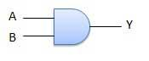

Truth Table
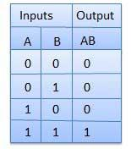

OR Gate
A circuit which performs an OR operation is shown in figure. It has n input (n >= 2) and one output.
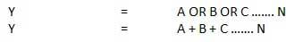

Logic diagram


Truth Table
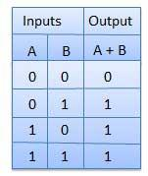

NOT Gate
NOT gate is also known as Inverter. It has one input A and one output Y.


Logic diagram


Truth Table
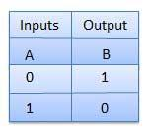

NAND Gate
A NOT-AND operation is known as NAND operation. It has n input (n >= 2) and one output.


Logic diagram
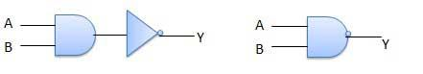

Truth Table
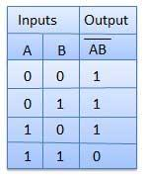

NOR Gate
A NOT-OR operation is known as NOR operation. It has n input (n >= 2) 2and one output.


Logic diagram


Truth Table
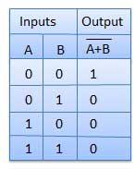

XOR Gate
XOR or Ex-OR gate is a special type of gate. It can be used in the half adder, full adder and subtractor. The exclusive-OR gate is abbreviated as EX-OR gate or sometime as X-OR gate. It has n input (n >= 2) and one output.


Logic diagram


Truth Table
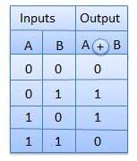

XNOR Gate
XNOR gate is a special type of gate. It can be used in the half adder, full adder and subtractor. The exclusive-NOR gate is abbreviated as EX-NOR gate or sometime as X-NOR gate. It has n input (n >= 2) and one output.


Logic diagram


Truth Table
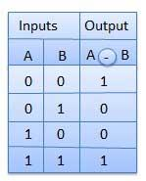

Overview - NAND gates

The NAND gate can be used to make every other logic gate. This is a good idea because logic circuits made entirely of NAND gates may:
- Use less logic gates
- Use less ICs and therefore be cheaper
- Be easier to build
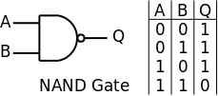The NAND gate has the truth table shown. The output is logic 0 when both the inputs are logic 1, otherwise the output is logic 1.

The NOT gate
A NOT gate can be made from a NAND gate with the two inputs connected together.
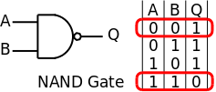When the two inputs are connected together the only possible options are A and B are both Logic 0 and so the output is Logic 1 or A and B are both Logic 1 and so the output is Logic 0.

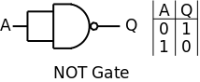To make a NOT gate from a NAND gate, simply connect the two inputs of the NAND gate together.

The AND gate
An AND gate is simply the inverse of a NAND gate and so following a NAND gate with a NOT gate (made from a NAND gate) gives the logic equivalent of an AND gate.
The first logic gate is the NAND gate. The second logic gate is a NOT gate which inverts the output of the NAND gate to give the output required for an AND gate.

The OR gate
An OR gate is slightly more complicated to make from NAND gates. Three NAND gates are needed, two of them acting as NOT gates.
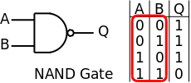Looking at the inputs of the NAND gate it is clear that the truth table would give the correct output for an OR gate if all the inputs were inverted.

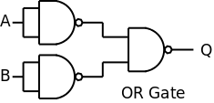To make an OR gate use two NAND gates as NOT gates to invert the inputs to the remaining NAND gate.

The NOR gate
A NOR gate is simply the inverse of an OR gate and so following a NOR gate (made from NAND gates) with a NOT gate (made from a NAND gate) gives the logic equivalent of a NOR gate.
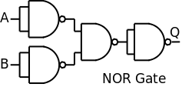The first three logic gates make the OR gate. The final logic gate acts as an inverter and makes the OR gate into a NOR gate. The NOR gate is made from four NAND gates and is therefore not always worthwhile (there are four NAND gates on an IC) but sometimes the NOT gates cancel making it worthwhile.

The NOT NOT situation
A NOT gate followed by another NOT gate has no effect on the logic signal. Two NOT gates in series are equivalent to a direct connection.
If A=1 then the output from the first NOT gate is Logic 0 and the output from the second NOT gate is Logic 1 and vice versa. In both cases A=Q and the two logic gates have no effect on the logic level of the signal.

Two NOT gates in series do, however, have an effect on the signal - each gate introduces a very small-time delay in the signal so multiple NOT gates can be used to give a delay to avoid synchronization problems.

Circuit example
Consider the simple circuit shown. It contains three different logic gates and requires three different ICs to make it.

All of the logic gates are replaced with their NAND gate equivalents. This requires 6 logic gates and therefore two ICs which is an improvement.

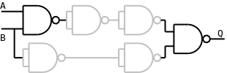In two places a NOT gate follows a NOT gate and so these cancel and can be removed - shown in grey.

Therefore, the entire circuit can be reduced to just two logic gates which can be built with one IC - much better.

What is a Binary Number System?
Binary Number System: According to digital electronics and mathematics, a binary number is defined as a number that is expressed in the binary system or base 2 numeral system. It describes numeric values by two separate symbols; 1 (one) and 0 (zero). The base-2 system is the positional notation with 2 as a radix.
The binary system is applied internally by almost all latest computers and computer-based devices because of its direct implementation in electronic circuits using logic gates. Every digit is referred to as a bit.
Example: Convert 4 in binary.
Solution:
4 in binary is (100)₂.
Here, 4 is represented in the decimal number system, where we can represent the number using the digits from 0-9. However, in a binary number system, we use only two digits, such as 0 and 1.
Now, let’s discuss how to convert 4 in binary number system. The following steps help to convert 4 in binary.
Step 1: First, divide the number 4 by 2. Use the integer quotient obtained in this step as the dividend for the next step. Continue this step, until the quotient becomes 0.
Dividend | Remainder
4/2 = 2 | 0
2/2 = 1 | 0
1/2 = 0 | 1
Step 2: Now, write the remainder in reverse chronological order. (i.e. from bottom to top).
Here, the Least Significant Bit (LSB) is 0 and the Most Significant Bit (MSB) is 1.
Hence, the decimal number 4 in binary is 100₂
So, if we want to find how many bits does 4 in binary have? we have to count the number of zeros and ones.
So, 4 in binary is 100₂. Here, there are 2 zeroes and 1 one. Hence, we have 3 bits.
Therefore, the number of bits does 4 in binary have is 3.

What is Bit in Binary Number?
A single binary digit is called a “Bit”. A binary number consists of several bits. Examples are:
- 10101 is a five-bit binary number
- 101 is a three-bit binary
- Binary Numbers Table
Some of the binary notations of lists of decimal numbers from 1 to 30, are mentioned in the below list.

Number | Binary Number | Number | Binary Number | Number | Binary Number
1 | 1 | 11 | 1011 | 21 | 10101
2 | 10 | 12 | 1100 | 22 | 10110
3 | 11 | 13 | 1101 | 23 | 10111
4 | 100 | 14 | 1110 | 24 | 11000
5 | 101 | 15 | 1111 | 25 | 11001
6 | 110 | 16 | 10000 | 26 | 11010
7 | 111 | 17 | 10001 | 27 | 11011
8 | 1000 | 18 | 10010 | 28 | 11100
9 | 1001 | 19 | 10011 | 29 | 11101
10 | 1010 | 20 | 10100 | 30 | 11110

How to Calculate Binary Numbers
For example, the number to be operated is 1235.
Thousands | Hundreds | Tens | Ones
1 | 2 | 3 | 5
This indicates,
1235 = 1 × 1000 + 2 × 100 + 3 × 10 + 5 × 1
Given,
1000 | = 10³ = 10 × 10 × 10
100 | = 10² = 10 × 10
10 | = 10¹ = 10
1 | = 10⁰ (any value to the exponent zero is one)
The above table can be described as,
Thousands | Hundreds | Tens | Ones
10³ | 10² | 10¹ | 10⁰
1 | 2 | 3 | 5
Hence,
1235 = 1 × 1000 + 2 × 100 + 3 × 10 + 5 × 1
= 1 × 10³ + 2 × 10² + 3 × 10¹ + 5 × 10⁰
The decimal number system operates in base 10, wherein the digits 0-9 represent numbers. In binary system operates in base 2 and the digits 0-1 represent numbers, and the base is known as radix. Put differently, and the above table can also be shown in the following manner.+
Thousands | Hundreds | Tens | Ones
Decimal | 10³ | 10² | 10¹ | 10⁰
Binary | 2³ | 2² | 2¹ | 2⁰
We place the digits in columns 10⁰, 10¹ and so on in base 10. When there is a need to put a value higher than 9 in the form of 10^{(n+1)} for instance, to add 10 to column 10⁰, you need to add 1 to the column 10¹.
We place the digits in columns 2⁰, 2¹ and so on in base 2. To place a value that is higher than 1 in 2^{n}, you need to add 2^{(n+1)}. For instance, to add 3 to column 2⁰, you need to add
What is Algorithm?
Therefore, Algorithm refers to a sequence of finite steps to solve a particular problem.
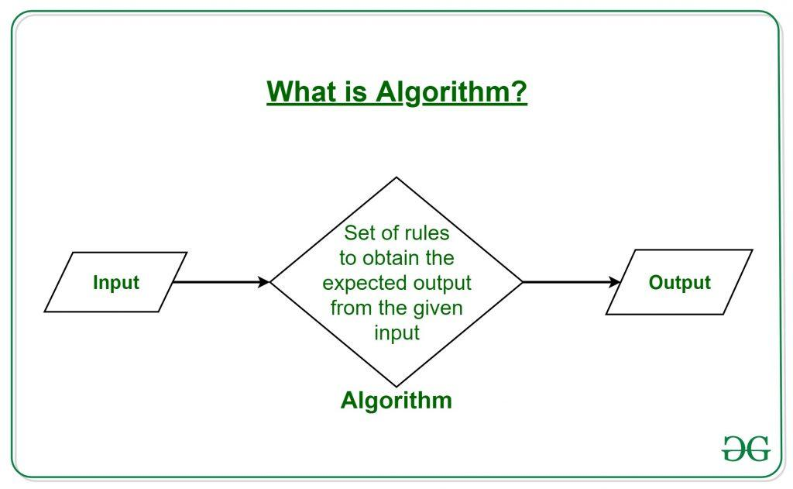

What are the Characteristics of an Algorithm?

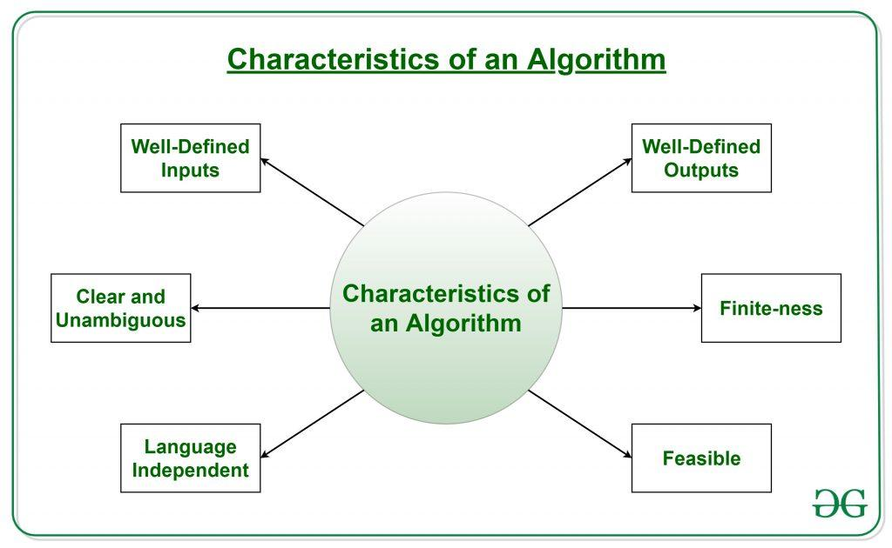

Definition of Flowchart
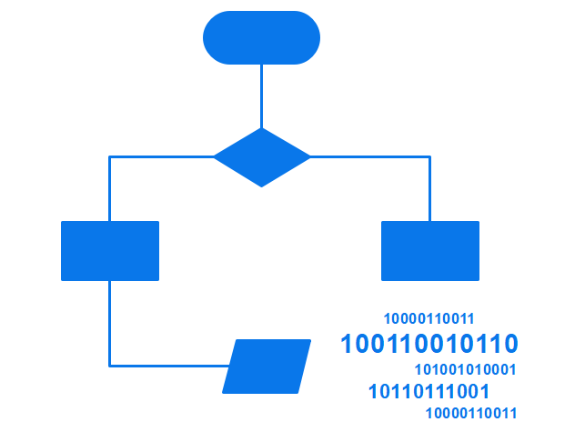
A flowchart is the graphical or pictorial representation of an algorithm with the help of different symbols, shapes, and arrows to demonstrate a process or a program. With algorithms, we can easily understand a program. The main purpose of using a flowchart is to analyze different methods. Several standard symbols are applied in a flowchart:
Common Abbreviations Used in P&ID
Terminal Box - Start / End | 
Input / Output | 
Process / Instruction | 
Decision | 
Connector / Arrow | 
The symbols above represent different parts of a flowchart. The process in a flowchart can be expressed through boxes and arrows with different sizes and colors. In a flowchart, we can easily highlight certain elements and the relationships between each part.
Tips:
During the reading of this article, if you find an icon type picture that you are interested in, you can download EdrawMax products to discover more or experience creating a free diagram of your own. All drawings are from EdrawMax.
Free DownloadFor Win 7 or later(64-bit)
Free DownloadFor macOS 10.14 or later
Difference between Algorithm and Flowchart
If you compare a flowchart to a movie, then an algorithm is the story of that movie. In other words, an algorithm is the core of a flowchart. Actually, in the field of computer programming, there are many differences between algorithm and flowchart regarding various aspects, such as the accuracy, the way they display, and the way people feel about them. Below is a table illustrating the differences between them in detail.
Algorithm
- It is a procedure for solving problems.
- The process is shown in step-by-step instruction.
- It is complex and difficult to understand.
- It is convenient to debug errors.
- The solution is showcased in natural language.
- It is somewhat easier to solve complex problem.
- It costs more time to create an algorithm.
Flowchart
- It is a graphic representation of a process.
- The process is shown in block-by-block information diagram.
- It is intuitive and easy to understand.
- It is hard to debug errors.
- The solution is showcased in pictorial format.
- It is hard to solve complex problem.
- It costs less time to create a flowchart.

EdrawMaxEdrawMax is a powerful, all-in-one, and yet easy-to-use diagramming tool that enables users to visualize the ideas effortlessly.
Download
EdrawMax provides beginners and pros the cutting-edge functionalities to build professional-looking diagrams easier, faster, and cheaper! It allows you to create more than 280 types of diagrams and should be an excellent Visio alternative.
Types of Algorithm
It is not surprising that algorithms are widely used in computer programming. However, it can be applied to solving mathematical problems and even in everyday life. Here comes a question: how many types of algorithms? According to Dr. Christoph Koutschan, a computer scientist working at the Research Institute for Symbolic Computation (RISC) in Austria, he has surveyed voting for the important types of algorithms. As a result, he has listed 32 crucial algorithms in computer science. Despite the complexity of algorithms, we can generally divide algorithms into six fundamental types based on their function.

Use Flowcharts to Represent Algorithms
Now that we have learned the definitions of algorithm and flowchart, how can we use a flowchart to represent an algorithm? To create an algorithm flowchart, we need to use a handy diagramming tool like EdrawMax to finish the work.
image / video 16:9
Algorithms are mainly used for mathematical and computer programs, whilst flowcharts can be used to describe all sorts of processes: business, educational, personal, and algorithms. So flowcharts are often used as a program planning tool to organize the program's step-by-step process visually. Here are some examples:

Example 1: Print 1 to 20:
Algorithm:
- Step 1: Initialize X as 0,
- Step 2: Increment X by 1,
- Step 3: Print X,
- Step 4: If X is less than 20 then go back to step 2.
Flowchart:
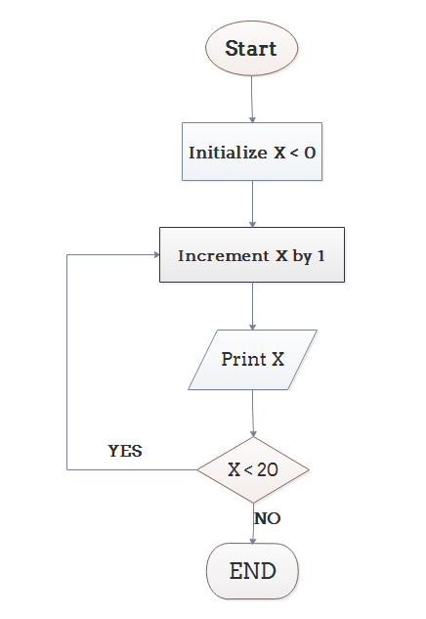Click to download and use this template.
While The eddx file need to be opened in EdrawMax.
If you don't have EdrawMax yet, you could download EdrawMax free from below.

Flowchart Algorithm

Example 2: Convert Temperature from Fahrenheit (℉) to Celsius (℃)
Algorithm:
- Step 1: Read temperature in Fahrenheit,
- Step 2: Calculate temperature with formula C=5/9*(F-32),
- Step 3: Print C.
Flowchart:
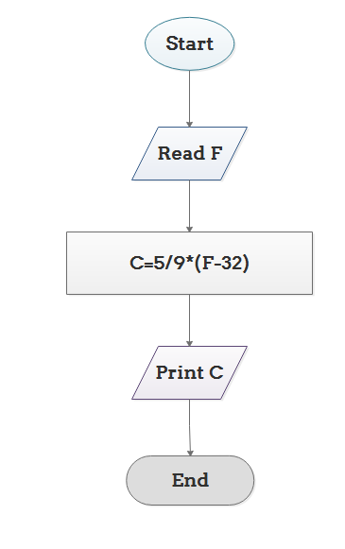Click to download and use this template.
While The eddx file need to be opened in EdrawMax.
If you don't have EdrawMax yet, you could download EdrawMax free from below.

Flowchart Algorithm 2

Example 3: Determine Whether A Student Passed the Exam or Not:
Algorithm:
- Step 1: Input grades of 4 courses M1, M2, M3 and M4,
- Step 2: Calculate the average grade with formula "Grade=(M1+M2+M3+M4)/4"
- Step 3: If the average grade is less than 60, print "FAIL", else print "PASS".
Flowchart:
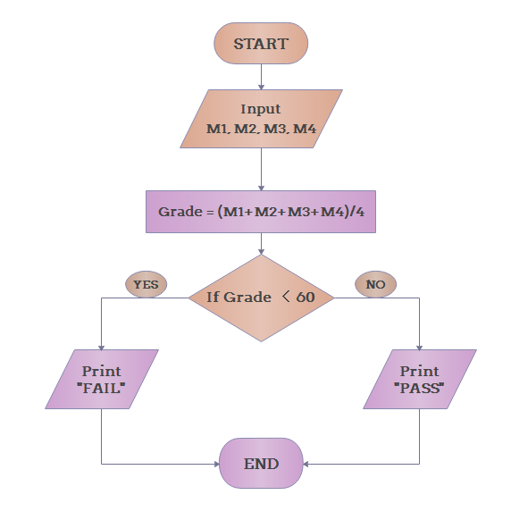Click to download and use this template.
While The eddx file need to be opened in EdrawMax.
If you don't have EdrawMax yet, you could download EdrawMax free from below.

Algorithm Flowchart Example 3

Tips:
During the reading of this article, if you find an icon type picture that you are interested in, you can download EdrawMax products to discover more or experience creating a free diagram of your own. All drawings are from EdrawMax.
Free DownloadFor Win 7 or later(64-bit)
Free DownloadFor macOS 10.14 or later

Conclusion
From the above, we can conclude that a flowchart is a pictorial representation of an algorithm, an algorithm can be expressed and analyzed through a flowchart. An algorithm shows you every step of reaching the final solution, while a flowchart shows you how to carry out the process by connecting each step. An algorithm uses mainly words to describe the steps while you can create a flowchart with flowchart symbols to make the process more logical.

C++ Variable Types

A variable provides us with named storage that our programs can manipulate. Each variable in C++ has a specific type, which determines the size and layout of the variable's memory; the range of values that can be stored within that memory; and the set of operations that can be applied to the variable.
The name of a variable can be composed of letters, digits, and the underscore character. It must begin with either a letter or an underscore. Upper and lowercase letters are distinct because C++ is case-sensitive −
There are following basic types of variable in C++ as explained in last chapter −
Sr.No | Type & Description
1 | bool  Stores either value true or false.
2 | char  Typically a single octet (one byte). This is an integer type.
3 | int  The most natural size of integer for the machine.
4 | float  A single-precision floating point value.
5 | double  A double-precision floating point value.
6 | void  Represents the absence of type.
7 | wchar_t  A wide character type.
C++ also allows to define various other types of variables, which we will cover in subsequent chapters like Enumeration, Pointer, Array, Reference, Data structures, and Classes.
Following section will cover how to define, declare and use various types of variables.

Variable Definition in C++
A variable definition tells the compiler where and how much storage to create for the variable. A variable definition specifies a data type, and contains a list of one or more variables of that type as follows −
type variable_list;
Here, type must be a valid C++ data type including char, w_char, int, float, double, bool or any user-defined object, etc., and variable_list may consist of one or more identifier names separated by commas. Some valid declarations are shown here −
int i, j, k;
char c, ch;
float f, salary;
double d;
The line int i, j, k; both declares and defines the variables i, j and k; which instructs the compiler to create variables named i, j and k of type int.
Variables can be initialized (assigned an initial value) in their declaration. The initializer consists of an equal sign followed by a constant expression as follows −
type variable_name = value;
Some examples are −
extern int d = 3, f = 5; // declaration of d and f.
int d = 3, f = 5; // definition and initializing d and f.
byte z = 22; // definition and initializes z.
char x = 'x'; // the variable x has the value 'x'.
For definition without an initializer: variables with static storage duration are implicitly initialized with NULL (all bytes have the value 0); the initial value of all other variables is undefined.

Variable Declaration in C++
A variable declaration provides assurance to the compiler that there is one variable existing with the given type and name so that compiler proceed for further compilation without needing complete detail about the variable. A variable declaration has its meaning at the time of compilation only, compiler needs actual variable definition at the time of linking of the program.
A variable declaration is useful when you are using multiple files and you define your variable in one of the files which will be available at the time of linking of the program. You will use extern keyword to declare a variable at any place. Though you can declare a variable multiple times in your C++ program, but it can be defined only once in a file, a function or a block of code.

Example
Try the following example where a variable has been declared at the top, but it has been defined inside the main function −
Live Demo
#include <iostream>
using namespace std;

// Variable declaration:
extern int a, b;
extern int c;
extern float f;

int main () {
// Variable definition:
int a, b;
int c;
float f;

// actual initialization
a = 10;
b = 20;
c = a + b;

cout << c << endl ;

f = 70.0/3.0;
cout << f << endl ;

return 0;
}
When the above code is compiled and executed, it produces the following result −
30
23.3333
Same concept applies on function declaration where you provide a function name at the time of its declaration and its actual definition can be given anywhere else. For example −
// function declaration
int func();
int main() {
// function call
int i = func();
}

// function definition
int func() {
return 0;
}

Lvalues and Rvalues
There are two kinds of expressions in C++ −
- lvalue − Expressions that refer to a memory location is called "lvalue" expression. An lvalue may appear as either the left-hand or right-hand side of an assignment.
- rvalue − The term rvalue refers to a data value that is stored at some address in memory. An rvalue is an expression that cannot have a value assigned to it which means an rvalue may appear on the right- but not left-hand side of an assignment.
Variables are lvalues and so may appear on the left-hand side of an assignment. Numeric literals are rvalues and so may not be assigned and can not appear on the left-hand side. Following is a valid statement −
int g = 20;
But the following is not a valid statement and would generate compile-time error −
10 = 20;
Previous Page Print PageNext Page

C++ Getting Started
❮ PreviousNext ❯

C++ Get Started
To start using C++, you need two things:
- A text editor, like Notepad, to write C++ code
- A compiler, like GCC, to translate the C++ code into a language that the computer will understand
There are many text editors and compilers to choose from. In this tutorial, we will use an IDE (see below).

C++ Install IDE
An IDE (Integrated Development Environment) is used to edit AND compile the code.
Popular IDE's include Code::Blocks, Eclipse, and Visual Studio. These are all free, and they can be used to both edit and debug C++ code.
Note: Web-based IDE's can work as well, but functionality is limited.
We will use Code::Blocks in our tutorial, which we believe is a good place to start.
You can find the latest version of Codeblocks at http://www.codeblocks.org/. Download the mingw-setup.exe file, which will install the text editor with a compiler.

C++ Quickstart
Let's create our first C++ file.
Open Codeblocks and go to File > New > Empty File.
Write the following C++ code and save the file as myfirstprogram.cpp (File > Save File as):

myfirstprogram.cpp
#include <iostream>
using namespace std;
int main() {
cout << "Hello World!";
return 0;
}
Don't worry if you don't understand the code above - we will discuss it in detail in later chapters. For now, focus on how to run the code.
In Codeblocks, it should look like this:
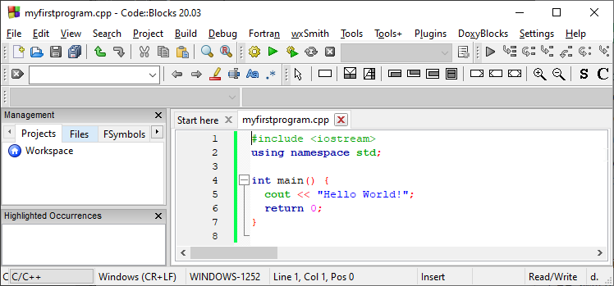
Then, go to Build > Build and Run to run (execute) the program. The result will look something to this:
Hello World!
Process returned 0 (0x0) execution time : 0.011 s
Press any key to continue.
Congratulations! You have now written and executed your first C++ program.

Learning C++ At W3Schools
When learning C++ at W3Schools.com, you can use our "Try it Yourself" tool, which shows both the code and the result. This will make it easier for you to understand every part as we move forward:

myfirstprogram.cpp
Code:
#include <iostream>
using namespace std;
int main() {
cout << "Hello World!";
return 0;
}
Result:
Hello World!
Try it Yourself »

❮ PreviousLog in to track progressNext ❯

